**Semester Project Documentation**

**Semester Project Title**: Online Book Store

**Student Details**

(Fill according to number of team/group members)

|  |  |  |  |
| --- | --- | --- | --- |
|  | Student Name | Student Reg # | Student Degree |
| Student-1 | Alishba Ramzan | 2022671 | Artificial intelligence |
| Student-2 | Syeda Noor Fatima | 2022669 | Artificial intelligence |
| Student-3 | Ayesha Khan | 2022133 | Artificial intelligence |

**Main Features**

*(Mention each by numbering as 1, 2, 3 … etc)*

1. Sign up for both seller and buyer
2. Login to already made account
3. Showing new books from time to time
4. Deleting outdated books
5. Buying books of interest

**Types of Users**

*(Just mention the types of users, For Example, Teachers, Students… etc.)*

Seller

Buyer

**Requirements Breakdown**

*(Write requirements of each feature by numbering. For example Requirements of feature # 1. It will be mentioned as 1.1, 1.2. Similarly, feature # 2 will be 2.1, 2.2, 2.3 … etc.)*

The seller can perform the following functions.

* 1. Makes an account on the website.
  2. Offers books in the fiction and non-fiction category.
  3. Add books to the store.
  4. Delete books from the store.
  5. Keep track of the cart.
  6. Display the cart at the end of purchasing books.

The buyer can perform the following functions.

2.1 Makes an account on the website.

2.2 Buy books of his/her interest.

**GUI Screens / Design / Wireframes**

*(Think about what kind of GUI your application should have. Make a simple and easy one, you don’t need to create a complex design, copy and paste a screenshot of your design under this heading)*

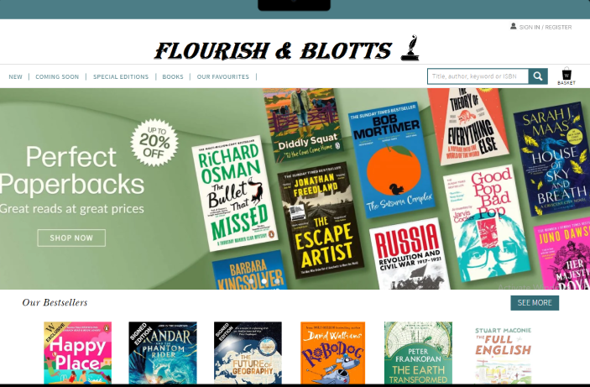

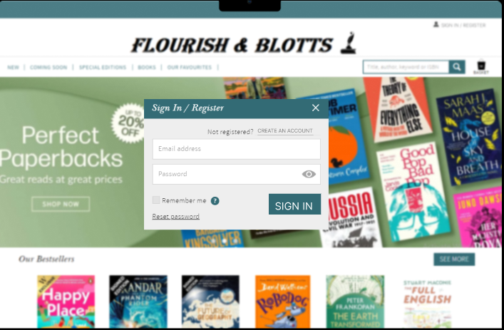

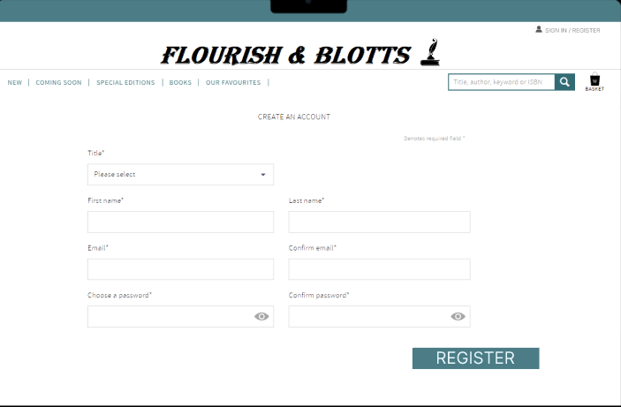

**Features of Codding Matrix**

*(In the following table you will mention the following items for each feature, mention the items in each column for each feature of your application)*

|  |  |  |  |  |  |
| --- | --- | --- | --- | --- | --- |
| Sr  no. | Feature Name | OOP Type Used | Functions Created | Variables / Obj Created | Line of Code Written |
| 1 | Sign up | Inheritance | signup() | seller  buyer | 26 |
| 2 | Log in | Inheritance | login() | seller  buyer | 26 |
| 3 | Add books to the store | Abstraction, Inheritance  Run type polymorphism | addBooksseller(AllBooks &)  addBooks() | seller | 30 |
| 4 | Delete books from the store | Abstraction, Inheritance  Run type polymorphism | deleteBooksseller(AllBooks &)  delBook() | seller | 35 |
| 5 | Buy books | Inheritance  Run type polymorphism | buybooksbuyer(AllBooks &)  buyBooks() | buyer | 28 |